Review: April 27th 2023:



1. Reduce spacing between the notification icon and profile. Space between notification, profile and profile details should be the same

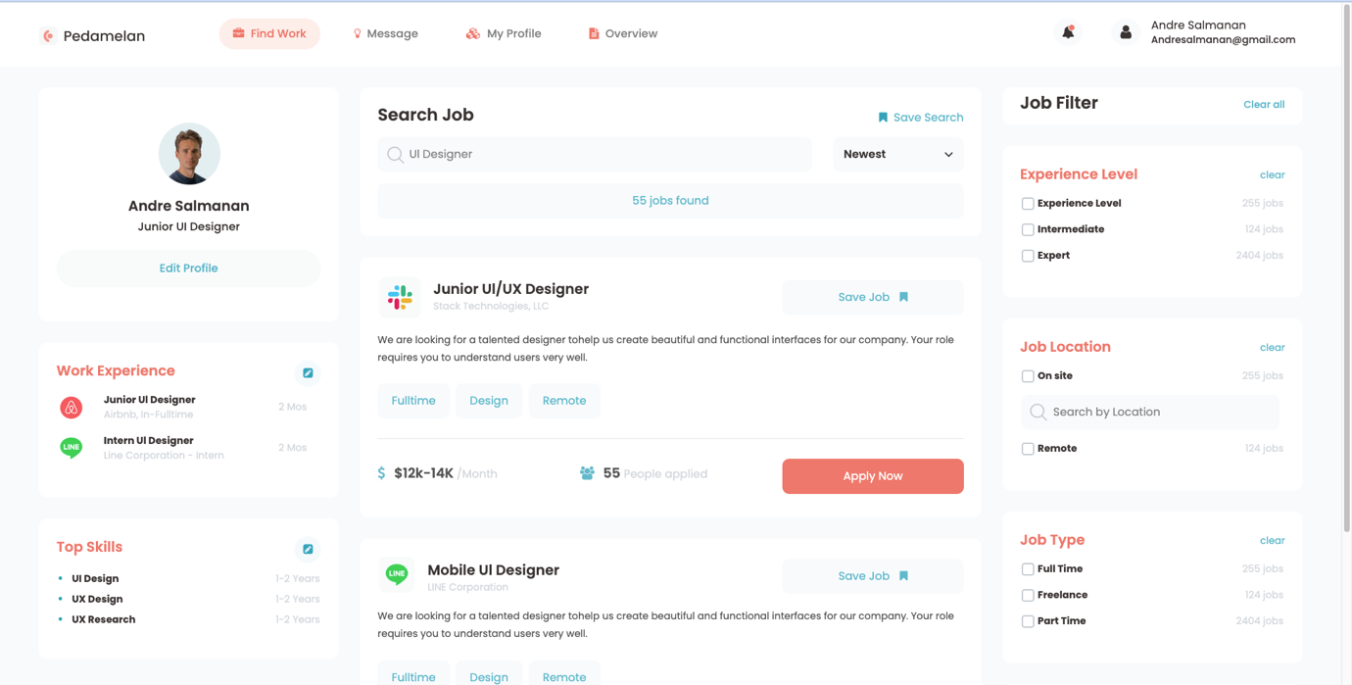

1. Can you fix the left and right sections during vertical scroll and make only the middle section is scroll



1. Reduce the size of “Job Filter” and align it properly



1. Vertical alignment is not proper

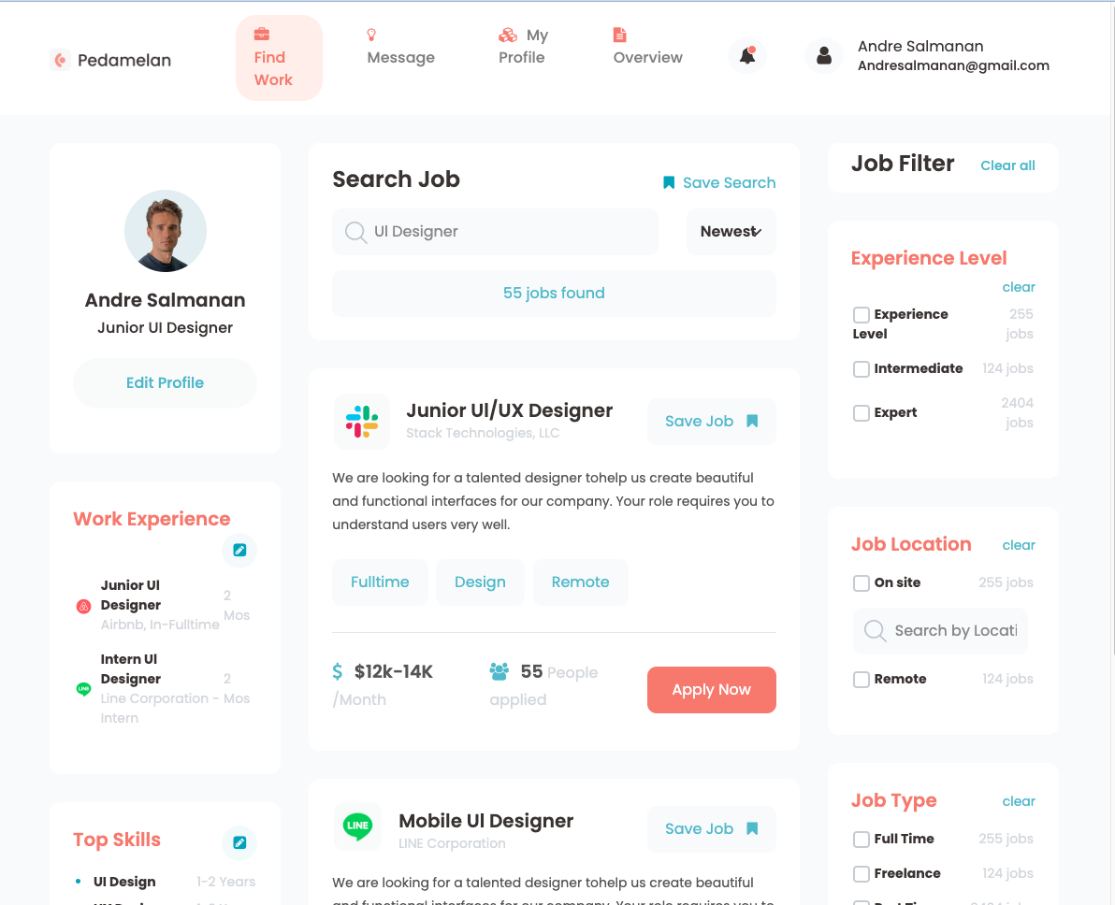

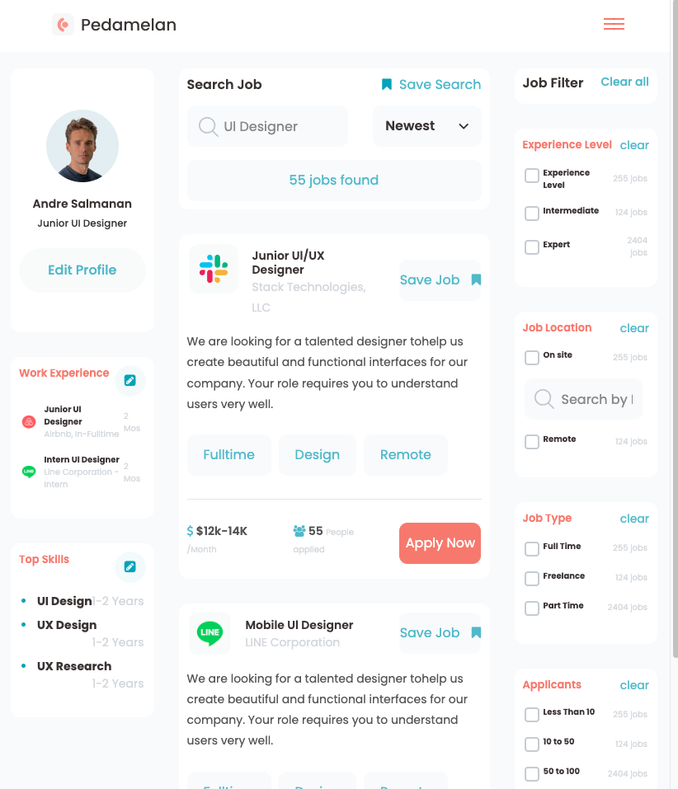

1. Responsiveness is not that good. Can you please look at it again?

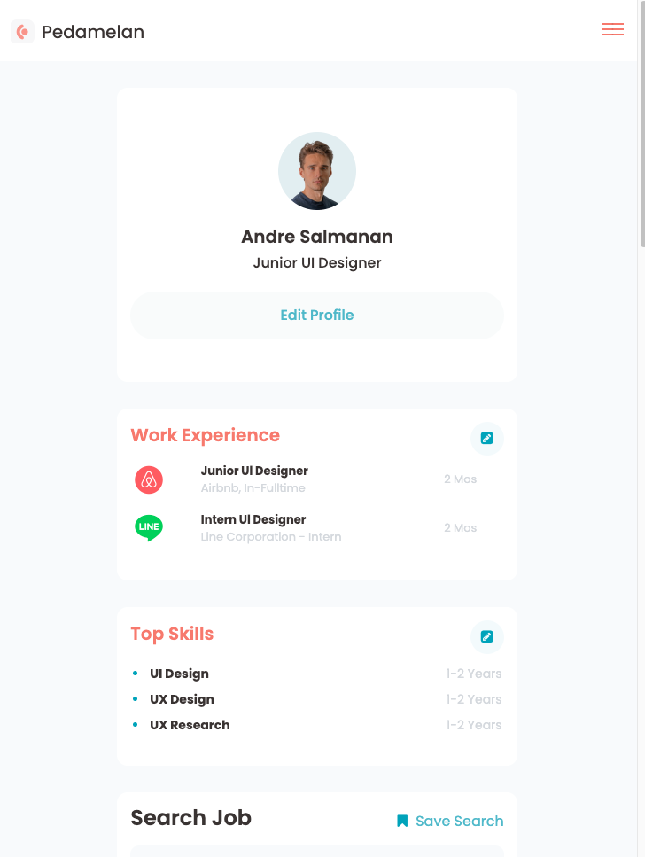

1. On mobile page can you bring left and right sections as sidebar (Kind of what you did for semrush website)

Only display middle section in the screen. Rest others, show as options in the sidebar

Review: April 30th 2023:

1. Enable Profile and Filter collapse at 974px itself

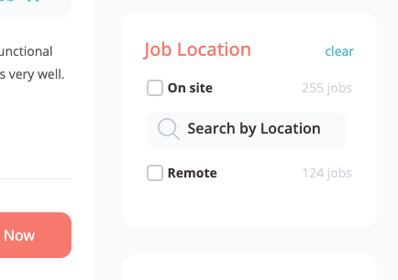

1. This “Search by Location” is not responsive as I reduce the screen size
2. Sticky fix the header at top as I scroll



1. In the Newest down arrow overlaps when the screen resizes

Review: May 1st 2023:



1. This “Search by Location” is not responsive as I reduce the screen size



1. In the Newest down arrow overlaps when the screen resizes